Week 2: Product and Category Management System
The store wants to maintain information about products and their categories. Each product belongs to a specific category, and the system should manage product details such as product name, price, and stock quantity.

Design Product and Category Tables

Category Table:
The Category table is created to store the details of different product categories such as Laptops, Cameras, Watches and Bags.

Product Table:
The Product table is created to store product details such as Product ID, Product Name, Category ID, Price and Stock Quantity.

The two tables for Category and Product have been created. Now, we have to find the relationship between the tables and apply constraints to the tables.

Define Relationships and Constraints

Relationships:
One Category can have many Products. The relationship between Category and Product is One-to-Many (1 → *). The Category_ID in the Category table is used to connect the Category table with the Product table.

Primary Key:
A Primary Key is a column or field that uniquely identifies each row or tuple in a table. In the Category table, Category_ID uniquely identifies each category. In the Product table, Product_ID uniquely identifies each product.
The Category_ID is assigned as the Primary Key for the Category table.
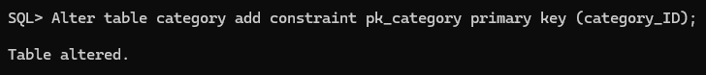
The Product_ID is assigned as the Primary Key for the Product table.
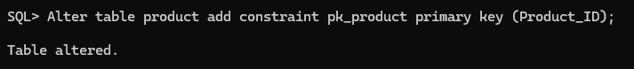

Foreign Key:

A Foreign Key is a key that links two tables. Therefore, Category_ID acts as the Foreign Key in the Product table.
The Category_ID in the Product table is connected with Category_ID in the Category table using a Foreign Key.

NOT NULL:
NOT NULL ensures that a column cannot have an empty or NULL value. For example, Category Name and Product Name should not be empty.
Category Name is made NOT NULL.
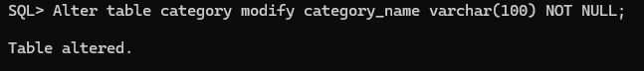

Product Name is made NOT NULL.

CHECK:
CHECK validates whether the values in a column satisfy a specified condition. For example, the price of a product must be greater than zero and stock quantity cannot be negative.
The price of a product must be greater than zero.
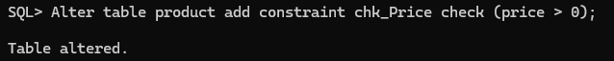
The stock quantity must be greater than or equal to zero.

UNIQUE:
UNIQUE ensures that duplicate values are not allowed in a column For example, two categories cannot have the same category name.
The Category Name is made UNIQUE.
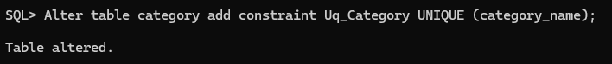
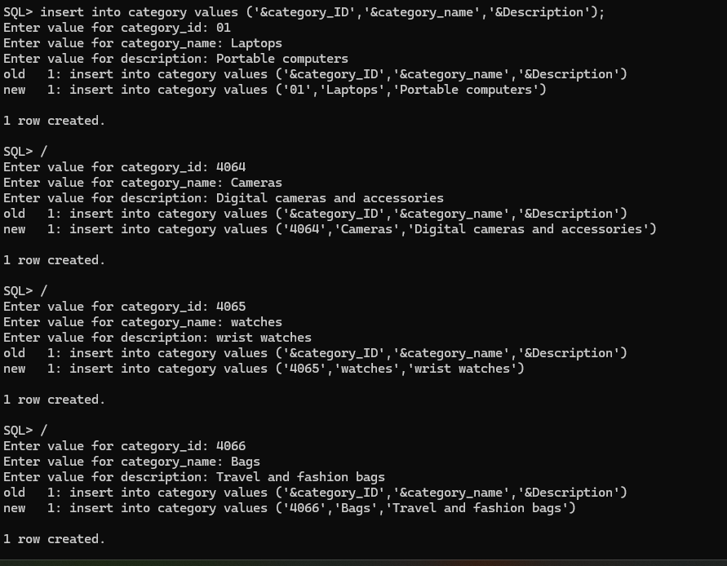
Insert Values

Category Table:

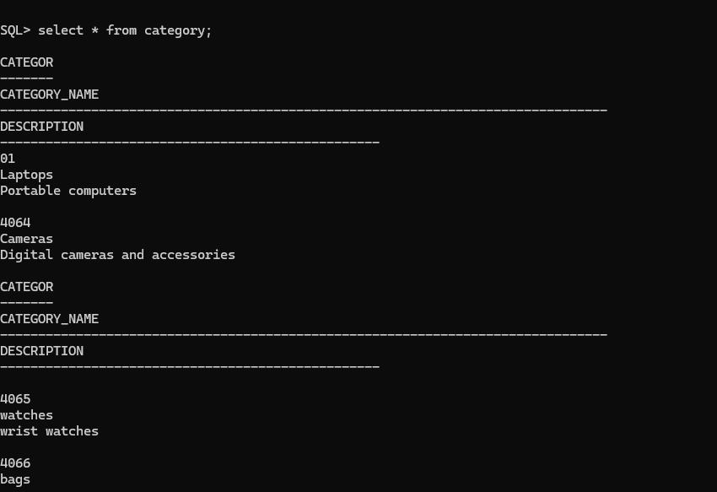
After Insertion – Category Table

Product Table
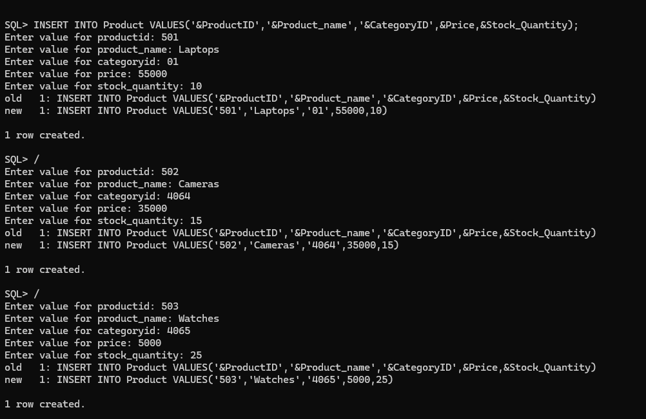
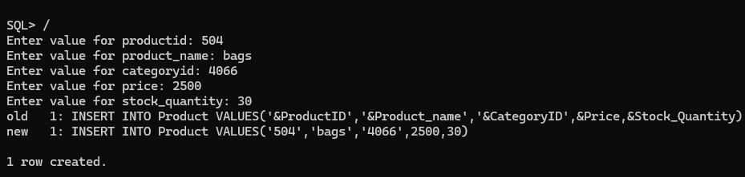
After Insertion –Product Table
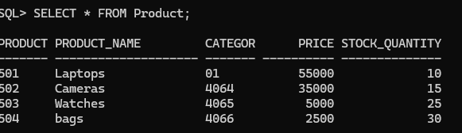
Insert Record

Update Price
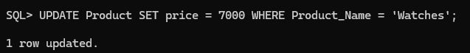
Delete a Product
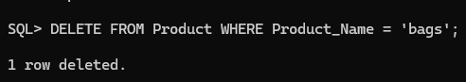
Generate Category-wise Product Reports
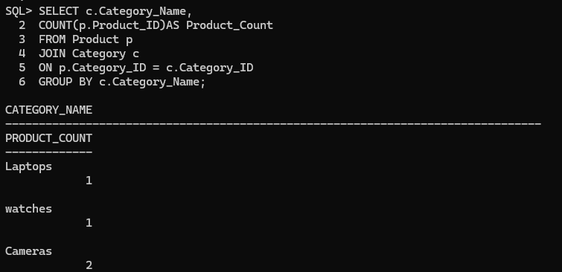
Count Number of Products in Each Category

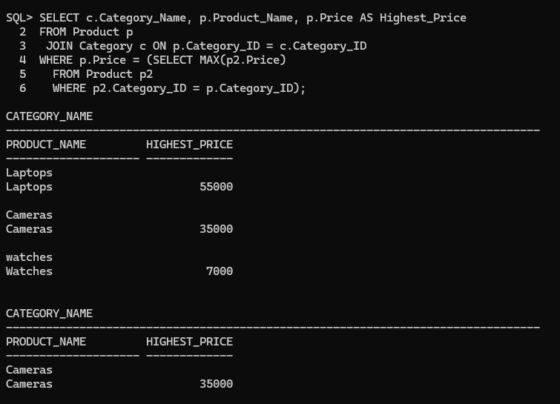
Find Highest-Priced Product in Each Category

Display Categories Having More Than 3 Products
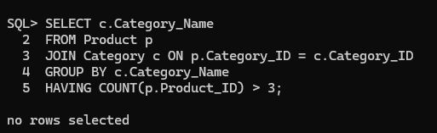
Find Average Product Price Category-wise
